PIZZA SALES SQL QUERIES
A. KPI’s
1. Total Revenue:
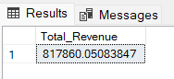
2. Average Order Value
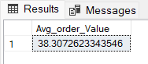
3. Total Pizzas Sold
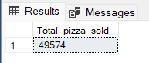
4. Total Orders
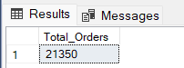
5. Average Pizzas Per Order
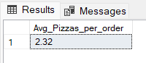

B. Daily Trend for Total Orders
Output:
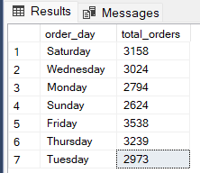
C. Monthly Trend for Orders
Output
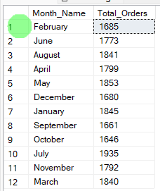

D. % of Sales by Pizza Category
Output
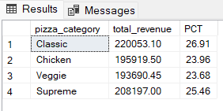
E. % of Sales by Pizza Size
Output
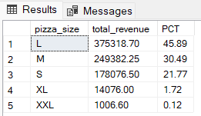
F. Total Pizzas Sold by Pizza Category
Output
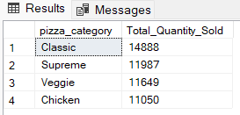

G. Top 5 Pizzas by Revenue
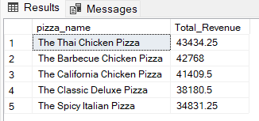
H. Bottom 5 Pizzas by Revenue
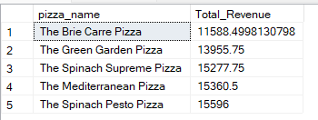
I. Top 5 Pizzas by Quantity
Output
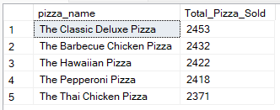

J. Bottom 5 Pizzas by Quantity
Output
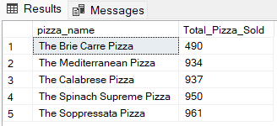
K. Top 5 Pizzas by Total Orders
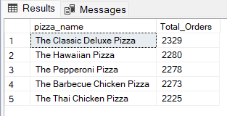
L. Borrom 5 Pizzas by Total Orders
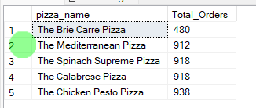
NOTE
If you want to apply the pizza_category or pizza_size filters to the above queries you can use WHERE clause. Follow some of below examples
SELECT Top 5 pizza_name, COUNT(DISTINCT order_id) AS Total_Orders
FROM pizza_sales
WHERE pizza_category = 'Classic'
GROUP BY pizza_name
ORDER BY Total_Orders ASC

